Image Brightness

Code:

import cv2
import numpy as np
image = cv2.imread("example.png")
new_image = cv2.resize(image, (400, 600))
cv2.imshow("Original Image", new_image)
brightness_factor = 50
bright_image = cv2.convertScaleAbs(new_image, alpha=1, beta=brightness_factor)
cv2.imshow("Brightened Image", bright_image)
cv2.imwrite("brightened_example.jpg", bright_image)
cv2.waitKey(0)
cv2.destroyAllWindows()

code output:
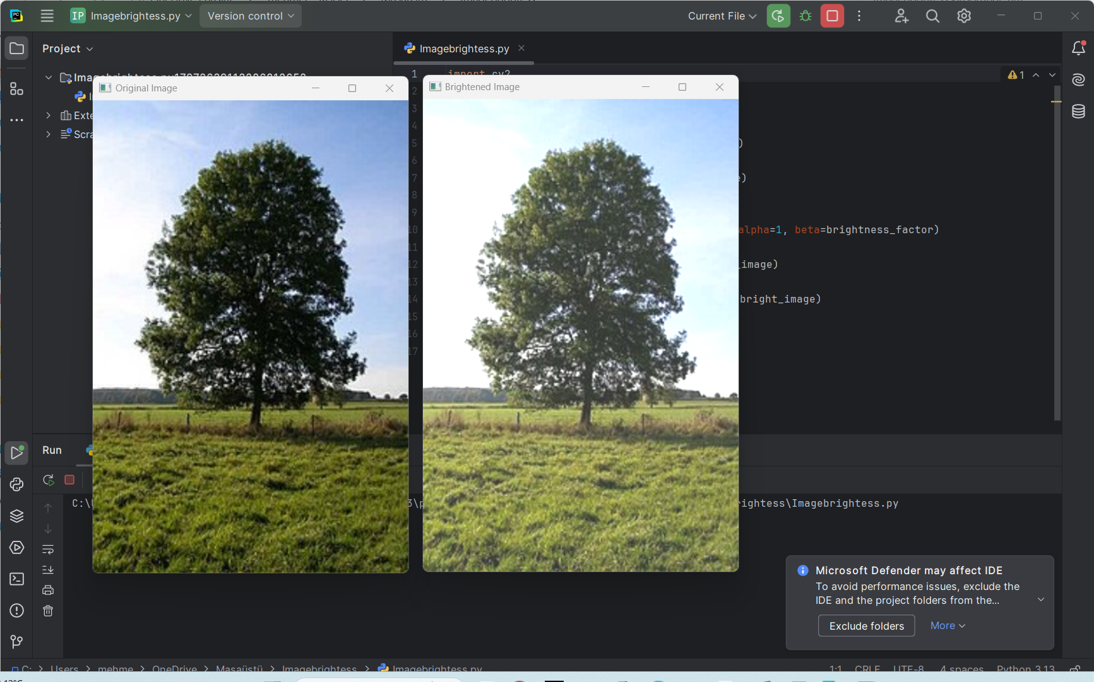
Code Explanation:
- Import Libraries:
  - cv2: This is the core library used for image processing tasks.
  - numpy: An optional library used for handling numerical operations (not directly needed in this case but useful for more complex operations).
- Loading the Image:
  - cv2.imread() reads the image file and loads it into memory as a NumPy array, which represents the image's pixel data.
- Adjusting Brightness:
  - alpha: This is a scaling factor for pixel intensity. It's kept at 1 to avoid changing the image’s contrast.
  - beta: This controls the brightness. A positive value increases the brightness, while a negative value darkens the image.
  - cv2.convertScaleAbs() performs the brightness adjustment based on the formula: new_pixel_value = alpha * old_pixel_value + beta.
- Display and Save the Image:
  - cv2.imshow() opens a window to display the original or modified image.
  - cv2.imwrite() saves the modified image to the disk with the specified filename.
- Final Clean-Up:
  - cv2.waitKey(0) keeps the image window open until a key is pressed.
  - cv2.destroyAllWindows() closes any open image windows once the program ends.

REPORT:
This project focuses on enhancing the brightness of images using Python and OpenCV. The process begins with loading an image using cv2.imread and resizing it to 400x600 pixels for standardization. Brightness is adjusted via the cv2.convertScaleAbs function, where alpha=1 maintains contrast, and beta=50 effectively increases brightness. The original and modified images are displayed side by side using cv2.imshow, and the adjusted image is saved to the disk as "brightened_example.jpg." The program ensures smooth execution by waiting for user input (cv2.waitKey(0)) and closing all windows with cv2.destroyAllWindows. This method provides a simple and efficient solution for brightness enhancement while maintaining image quality.

